INTERNSHIP REPORT
Title Page

Submitted by
Name: ANNA POLY
Program: B.Sc. Computer Science
Register no: PNAYSCS009
College: PRAJYOTI NIKETAN COLLEGE, PUDUKAD
University: CALICUT UNIVERSITY

Project Title: Hotel Booking System
Organization: ZIUKE INFOTECH THRISSUR
Duration: 60 Hours (Company Training Internship)
Technologies Used: Python, Django, HTML, CSS

Acknowledgment

I would like to express my sincere gratitude to ZIUKE INFOTECH for providing me with the opportunity to undergo a 60-hour internship as part of my B.Sc. Computer Science curriculum. I am thankful to the management and technical team for their guidance, training, and continuous support throughout the internship period.
I extend my heartfelt thanks to my internship supervisor for mentoring me during the development of the Hotel Booking System project and helping me understand real-world software development practices. I am also grateful to my college faculty coordinator for their encouragement and academic support.
Finally, I thank my friends and family for their constant motivation and support, which helped me successfully complete this internship.

Executive Summary

This internship report presents the work carried out during a 60-hour company training internship at ZIUKE INFOTECH . The primary objective of the internship was to gain practical exposure to web application development using modern technologies and frameworks.
During the internship, I worked on the development of a Hotel Booking System, a web-based application designed to allow users to search hotels, view room details, make bookings, and manage reservations efficiently. The system was developed using Python Django as the backend framework and HTML and CSS for frontend design.
The internship helped bridge the gap between theoretical knowledge gained during the B.Sc. Computer Science course and real-world application development. This report details the organization profile, internship overview, project experience, learning outcomes, and reflections gained during the internship.

Certificate

(Internship completion certificate from Zuike Technology is attached separately.)

TABLE OF CONTENTS

- Organization Profile…………………………………….6
- Internship Overview…………………………………….7
- Internship Experience – Hotel Booking System…………8
- Learning Reflection………………………………………10
- Appendix………………………………………………...10

Chapter 1: Organization Profile

  - About ZIUKE INFOTECH

ZIUKE INFOTECH is a technology-focused organization that provides software development, IT training, and digital solutions to individuals and businesses. The company focuses on developing scalable and efficient web-based applications using modern programming languages and frameworks.

  - Vision and Mission

Vision:
To become a leading provider of innovative and reliable software solutions and technical training.
Mission:
- To deliver high-quality software products that meet industry standards.
- To train students and professionals with practical, job-oriented technical skills.
- To encourage innovation and continuous learning.

  - Services Offered

- Web Application Development
- Software Training and Internships
- IT Consulting Services
- Project Development for Students

  - Organizational Structure

ZIUKE INFOTECH follows a structured organizational hierarchy consisting of management, project managers, developers, trainers, and interns. This structure ensures effective project execution and quality training.

Chapter 2: Internship Overview

2.1 Internship Details

- Organization: ZIUKE INFOTECH
- Duration: 60 Hours
- Type: Company Training Internship
- Course: B.Sc. Computer Science

2.2 Objectives of the Internship

The main objectives of the internship were:
- To gain hands-on experience in web development
- To understand the Django framework
- To learn frontend design using HTML and CSS
- To develop a real-time project from scratch

2.3 Training Methodology

The internship began with theoretical training sessions on Python and Django, followed by practical coding sessions. Regular tasks and assignments were provided to reinforce learning. The training concluded with the development of a complete project.

2.4 Tools and Technologies Used

- Programming Language: Python
- Framework: Django
- Frontend: HTML, CSS
- Development Tools: VS Code, Web Browser

Chapter 3: Internship Experience – Hotel Booking System

3.1 Project Introduction

The Hotel Booking System is a web-based application developed to simplify the process of booking hotel rooms online. It allows users to view hotel details, check room availability, and make reservations.

3.2 Project Objectives

- To provide an easy-to-use hotel booking platform
- To manage hotel and room information efficiently
- To allow users to book rooms online
- To store booking details securely

3.3 System Modules
- User Module
  - User registration and login
  - View hotel and room details

- Hotel Module
  - Display hotel information
  - Room details and pricing
- Booking Module
  - Room booking
  - Booking confirmation
- Admin Module
  - Manage hotels and rooms
  - View bookings

3.4 System Design

Models handle database operations, views manage business logic, and templates manage the user interface.
3.5 Database Design (Overview)

- User Table
- Hotel Table
- Room Table
- Booking Table
Each table is designed with appropriate fields, data types, and constraints to ensure data integrity.

3.6 Implementation Details

The backend was developed using Django, which handled URL routing, database interaction, and user authentication. HTML and CSS were used to design responsive and user-friendly interfaces.

3.7 Challenges Faced
- Understanding Django project structure
- Managing database relationships
- Designing user-friendly interfaces
These challenges were overcome with guidance from trainers and continuous practice.

Chapter 4: Learning Reflection
4.1 Technical Skills Gained
- Improved Python programming skills
- Hands-on experience with Django framework
- Knowledge of web application architecture
- Frontend development using HTML and CSS

4.2 Professional Skills Developed
- Time management
- Problem-solving skills
- Team communication
- Understanding of industry practices

4.3 Overall Experience
The internship was a valuable learning experience that enhanced both my technical and professional skills. It provided exposure to real-world project development and boosted my confidence in web application development.

Appendix
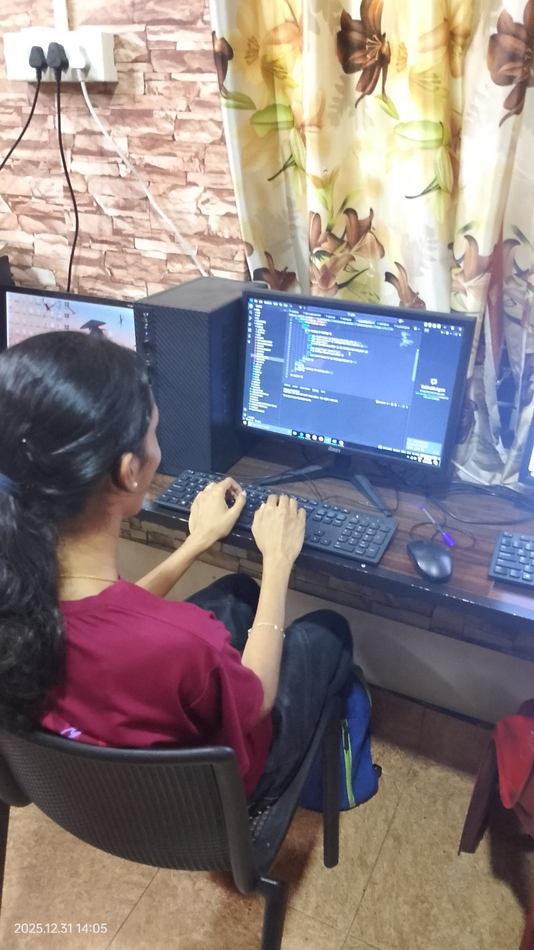

Worksheet
click here

